Solutions Plus, Inc.
Data Sheet



Bio-Remedia Plus - (Liquid Version)

Concentrate-Hydro Carbon Treatment (HCT)

A concentrated, liquid blend of stabilized bacterial spores and micronutrients formulated for cleaning and degradation of petroleum based hydrocarbons

Help The Environment With Bio-Remedia Plus

ADVANTAGES
BIO-REMEDIA PLUS contains a synergistic blend of petroleum degrading and organic waste degrading bacterial strains. (Basic Terms, consumes oils and hydrocarbons from the ground.

Each strain in BIO-REMEDIA PLUS was selected to work under diverse environmental conditions and provides the most complete digestion of petroleum and petroleum degradation by-products.

BIO-REMEDIA PLUS contains proven petroleum degrading strains. As shown in the two graphs on the right, gas chromatograph analysis confirmed that these strains metabolize hydrocarbon products such as gasoline, oil, diesel, and BTEX (Benzene, Toluene, Ethylbenzene, and Xylene).

The bacterial cultures in this blend are also beneficial in treating soil tainted with hydrocarbons. Soil treatments can be spray applied or tilled into the contaminated soil. The addition of nutrients in soil applications to balance the system often shows increased activity.

Railway Applications:

Spray tracks with Bio-Remedia Plus between tracks and on both sides. Bio-Remedia Plus starts working immediately on the oils that has seep into the ground. Once surface is soaked with the
Bio-Remedia Plus, degradation of petroleum based hydrocarbons begins.
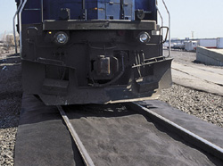

Locations to soak with Bio-Remedia Plus

Using concentration:

Use Bio-Remedia Plus at 1:3 to 1:4. (One gallon of Bio-Remedia Plus to 3 to 4 gallons of water)
Soak surface abundantly. Within minutes Bio-Remedia Plus starts digesting hydrocarbons.

BIO-REMEDIA PLUS Specifications

APPLICATIONS

Petroleum contaminated wastewater
Marine bilges
Car/Truck washes
Soil remediation
Rail Yards
Rail Tracks

PRODUCT PROFILE  Multiple Bacillus Species  • Naturally occurring, non-engineered  • Aerobes and facultative anaerobes  • Highly motile  • Positive chemotaxis  • 100% stabilized bacterial spores  BIO-REMEDIA PLUS should be applied at a rate of 1 gallon per 50 to 75 square foot of hard surface area or soil surface. The initial application should be applied with an even spray using an atomizing or non-atomizing spray head.  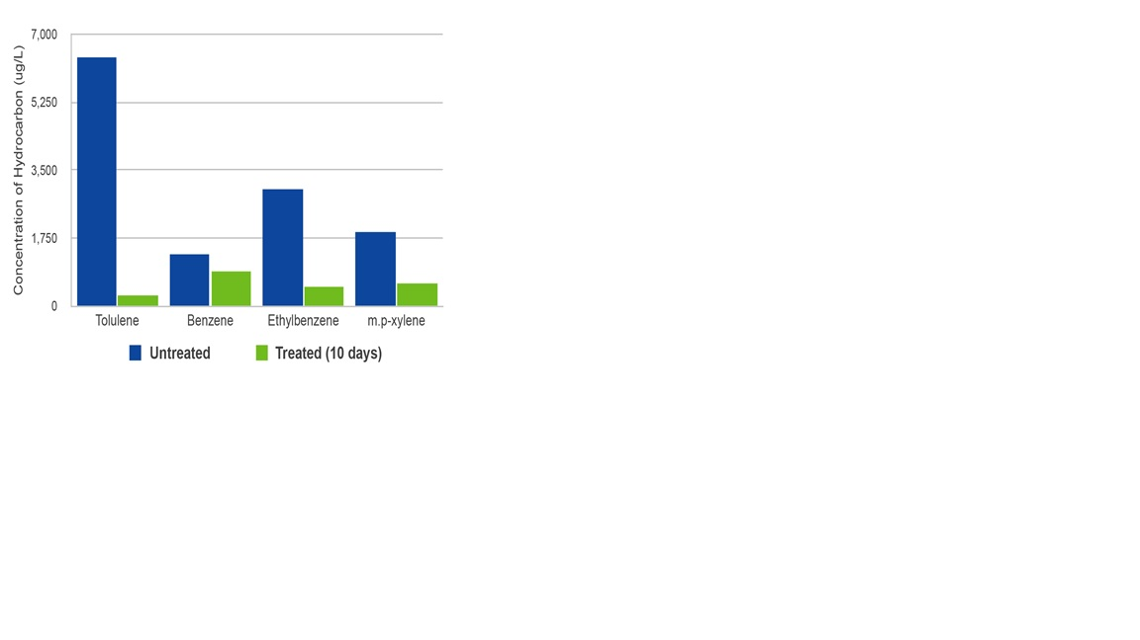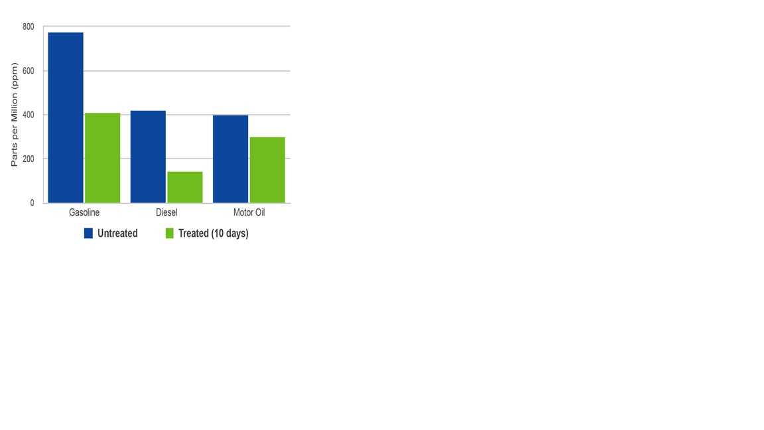 | Features/Advantages  - Rapidly cleans surfaces of spill components.  - Economical alternative to solvent based cleaners.  - Visual results in minutes  - Allows for further biodegradation above and below ground surface.  - Cleans oily equipment, vehicles and tools.

