SOLUTIONS PLUS CHEMICAL DATA

BLOCK STRIP PLUS-PRO
Heavy Duty Spray and Immersion Cleaner

DESCRIPTION

BLOCK STRIP PLUS-PRO is a heavy-duty liquid alkaline cleaner designed for use in both spray and immersion washers for the heavy soils in the transportation industry. Contains no chromates, phenols, or cresols. It is especially designed for industrial washers and is an excellent rust and paint stripper for re-manufactured parts. BLOCK STRIP PLUS-PRO is non-foaming and splits oil rapidly.

BLOCK STRIP PLUS-PRO will speed up strip-time on paint, rust and carbon. Because of BLOCK STRIP PLUS-PRO being very concentrated, wash time and concentration may be able to be reduced.

BLOCK STRIP PLUS-PRO penetrates paint, rust, carbon, oils and greases much faster than conventional chemicals on the market today.

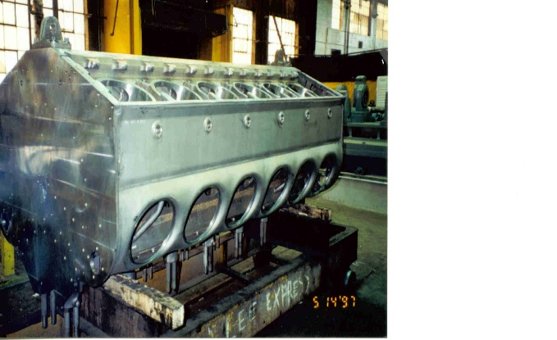

BLOCK STRIP PLUS-PRO can also be recycled by Solutions Plus’ patented recycling system.

PROPERTIES
Appearance: Clear Liquid
Odor: Mild
pH Reaction: >13
Solubility: Complete

USING PROCEDURES

Use 10% to 60% volume per gallon of water, at temperatures up to
180-190 F in spray washers and soak tanks.

DISPENSING

Use immersion or dispense through standard pump, or spray equipment.
SOLUTIONS PLUS., 3907 Bach Buxton Rd., Amelia, OH 45102

