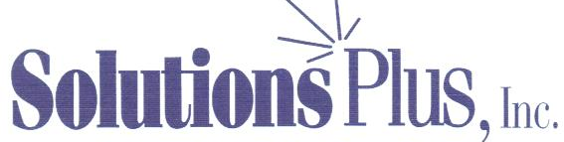
 Registered ISO 9001:2008 Manufacturer

INDUSTRIAL CHEMICAL PRODUCTS
Quality-Cost Savings-Service

CITRA CLEAN 500

DESCRIPTION

CITRA CLEAN 500 is a powerful blend of citrus and other non-petroleum solvents designed to handle the most difficult industrial cleaning challenges. CITRA CLEAN 500 can be used full strength or diluted with water depending on the cleaning job. At full strength it removes the most stubborn stains left by grease, oil, tar and even inks. Dilution with water allows economical medium and light duty cleaning on a variety of surfaces and has a pH of 10.8 @ 5%.

CITRA CLEAN 500 has a wide range of cleaning uses in both the industrial and transportation market place. It is formulated to provide rapid and complete rinsing, leaving no residue.

APPLICATIONS

Industrial floors, equipment, machinery, ships, walls, showers, stoves, air ducts, trains, cars, printing presses, counter tops, venetian blinds, light fixtures, tools.

Directions: Use full strength or dilute with water to apply to surface by means of the following: sprayers, mops, sponges, rags or towels. Do not allow the product to dry on the surface before rinsing.

Heavy Duty Cleaning:
Use full strength for the most stubborn marks and stains.

Heavy Carbonized Soils & Baked On Soils, grease, oils:
Use from full strength to a 1:1 mixture with water.

Medium Duty Cleaning:
Use from 1:1 to 1:10 with water.

Light Duty Cleaning:
Use from 1:10 to 1:20 with water.

