SOLUTIONS PLUS CHEMICAL DATA

DISSOLVE PLUS
GREASE ASPHALT AND CARBON REMOVER

DESCRIPTION

DISSOLVE PLUS is a solvent cleaner used to dissolve grease from metal surfaces. DISSOLVE PLUS works rapidly to remove heavy grease deposits, allowing parts to be reconditioned quickly. DISSOLVE PLUS works extremely well on engine blocks, piston heads, and any carbonized oily or greasy surfaces including asphalt and tar.

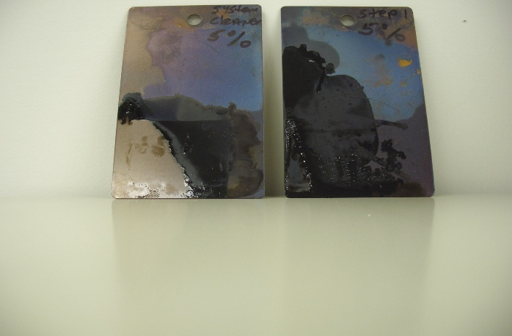

PROPERTIES

Appearance: Clear water white liquid
Odor: Mild Lemon
pH Not measurable
Flash Point: 147 F C.O.C

Safety: Safe on all metals
Specific Gravity: 0.780
lbs/Gal.: 6.50

USING PROCEDURES

Use DISSOLVE PLUS at full strength under immersion methods. Slight agitation of the part may be helpful in speeding up the cleaning process.

MATERIAL SAFETY

Safe on all metals.

STORAGE

Store in a cool area away from direct sunlight, open flames or sparks. Open drums slowly to vent.

_________________________________________________________________
Solutions Plus Inc., 3907 Bach Buxton Rd., Amelia, OH 45102
513-943-9600 Fax 513-943-9609

