Earth Solve Plus

(No Flash Point Fast Drying Solvent Degreaser)

Technical Benefits



Railway Industry
Has Dielectric Strength Of 13,800 Volts (ASTM D-877)
One of the most critical areas of a locomotive is the Traction Motor along with the armature and generator.

It Is Vitally Important That These Parts Are Kept Clean

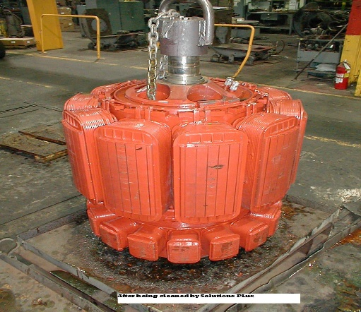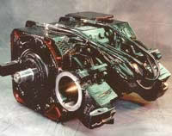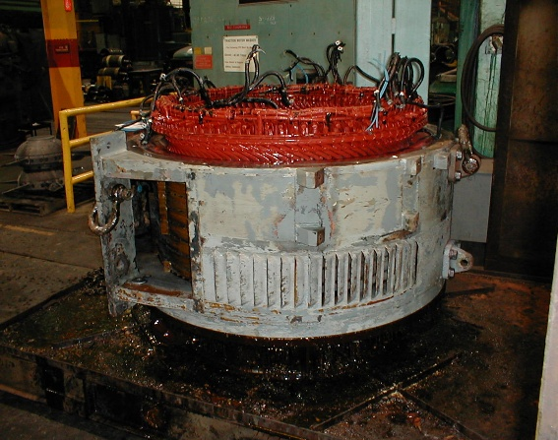

Up until know, solvents were used to spray on these units to keep them free of oil, rail-dust and contaminates. Many of these solvents are dangerous because of the flash point and the chance of causing a fire or even explosions. They also damaged the carbon brushes on the Traction Motors.

With Earth Solve Plus, there is no flash, it does not damage carbon brushes and dries in seconds.

When Earth Solve Plus is sprayed on the equipment, it leaves the area free of oil, contaminates and the surface is completely dry.
A list of railways using the Earth Solve Plus is available upon request.

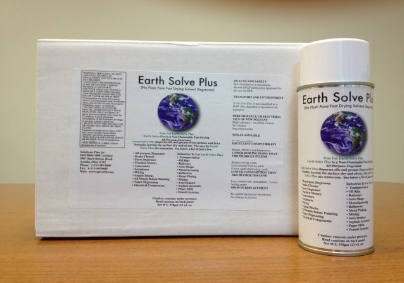
Earth Solve Plus comes in a convenient case of 12 aerosol cans for ease of use

Other Benefits Of Using Earth Solve Plus

*HEALTH AND SAFETY

Not classified as a carcinogen.
Recent SNAP publication approved for all uses by EPA.

*TRANSPORT AND ENVIRONMENT

Earth Solv Plus is not classified as a HAP.
Not classified as hazardous for transport.
*PERFORMANCE CHARACTERISTICS OF NEW SOLVENT

High solvency – excellent cleaner.
No residue.
Fast evaporating.
*NON-FLAMMABLE

No fire proofing.
*EXCELLENT COMPATIBILITY

Metals, Plastics and Elastomers.
* LOWER BOILING POINT THAN TRICHLOROETHYLENE

Reduce energy costs.
Less cooling time for parts.
Faster vapor degreasing cycle.
*LOWER CONSUMPTION THAN TRICHLOROETHYLENE

