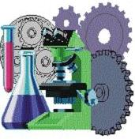

SOLUTIONS PLUS CHEMICAL DATA

RP EXTEND PLUS
RUST PREVENTATIVE

DESCRIPTION

RP EXTEND PLUS is an effective water displacing, non-staining rust preventive which will not emulsify even in the presence of alkali, and will quickly separate water displaced from metal surfaces after machining operations or after alkaline cleaning. The protective film of RP EXTEND PLUS is non-staining. It is recommended for protecting parts shipped overseas.

RP EXTEND PLUS does not contain Barium or other heavy metals. It provides up to 96 hours salt spray protection. RP EXTEND PLUS is fast drying and leaves a film which will provide long term indoor protection. This film has lubricity for added manufacturing advantages.

PROPERTIES

Appearance: Brown liquid
Odor: Mild
Specific Gravity: 0.881
Lbs/Gal.: 7.35

Using Procedures

RP ULTRA can be cleaned off of parts with a mild alkaline cleaner.

RP ULTRA can also be diluted with mineral spirits, but by doing so it may shorten the rust protection.

For ultimate rust protection, use undiluted.

