INDUSTRIAL METAL CLEANER #1

Technical Data
Appearance: Clear dark amber liquid
pH (1% Solution): 12.80
Specific gravity/Density: 1.22/(10.18 lbs/Gal.)
Odor: Slightly aromatic
Foam: Low, controlled
Solubility in H2: Immediate (liquid)
Phosphates: Yes
Silicates: None
Caustic: Yes

Use Instructions

Use Industrial Metal Cleaner #1 in spray washers at 2-5% by volume. Typical contact time is 60 to 90 seconds, but will vary based on soil load and spray impingement. Industrial Metal Cleaner #1 is used in the temperature range of 140°-175°

Best Practices:
To avoid foaming, the process water should be heated to the minimum recommended operating temperature (145°) prior to product addition. It is best to add Industrial Metal Cleaner #1 near the pump intake while the pump is operating.

For maximizing part cleanliness, Industrial Metal Cleaner #1 should be followed by a clean rinse. In every case, dry quickly to avoid flash rusting. If the parts are not going to be immediately painted, consult your Solutions Representative for the appropriate rust preventative to meet your corrosion protection requirements.

To maximize bath life, mechanically emulsified, free-floating oil should be skimmed or otherwise removed from the surface of the bath during any shut down period.

Dispensing
Industrial Metal Cleaner #1 can be easily dispensed and controlled using inductive conductivity controllers. Consult your local Solutions Representative for recommended equipment.

Metal Capability
Safe when used as directed on: steel, iron, stainless steel, nickel and copper. Brass and bronze will darken. Not safe on: aluminum, zinc, tin, galvanized, babbit or bearing metals cadmium.

Before

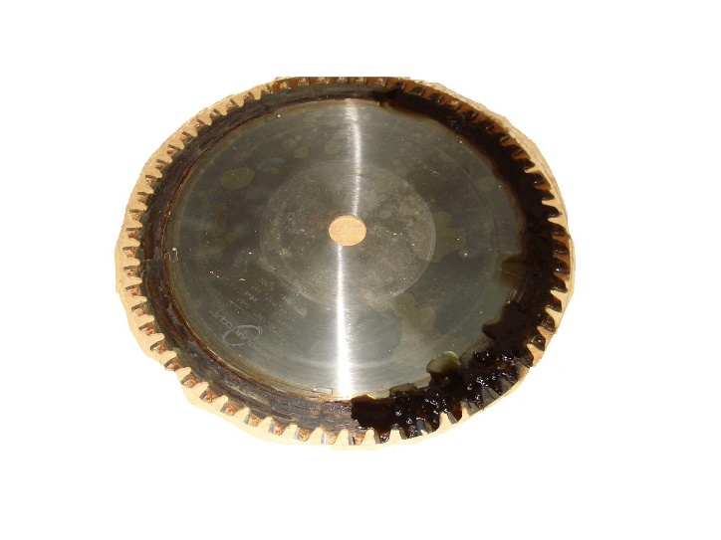After

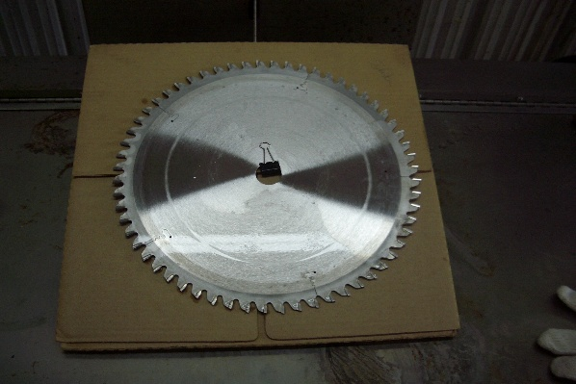

Industrial Metal Cleaner #1

Alkaline Spray Wash Cleaner for Ferrous Metals

Description

Industrial Metal Cleaner #1 is an excellent wash cleaner for steel prior to painting in iron or Zinc phosphatizing systems.
Removes heavy oil cutting and press working fluids, honing oils and water-soluble metalworking fluids. Industrial Metal Cleaner #1 ensures good formation of an iron or Zinc phosphate conversion coating by providing an exceptionally clean surface.

Key Properties
* For prepaint and in process cleaning applications
* Cleans most straight oil cutting and pressworking fluids, honing oils, and water soluble metalworking fluids
* Non-silicated, easy-to-rinse, no powdery residue left on parts; reduces the potential for rejects
* Helps ensure easy spot-free rinsing and minimizes carryover between wash and rinsing stages
* Liquid product; mixes quickly and is easy to dispense

Before & After Bolts before Zinc Phosphating

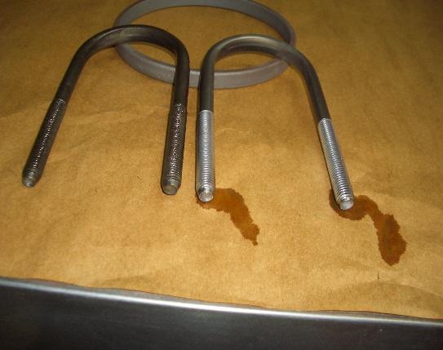

Locomotive Piston Before

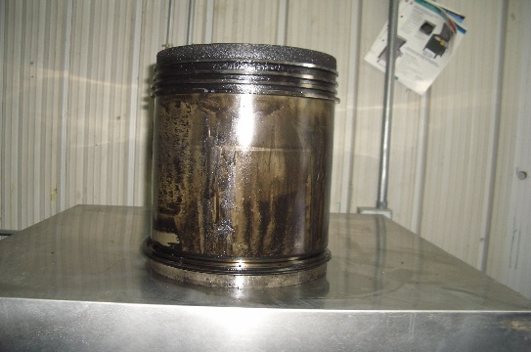

Locomotive Piston After

