
SOLUTIONS PLUS CHEMICAL DATA

MASTER CLEAN 17-90

DESCRIPTION

MASTER CLEAN 17-90 is a concentrated, non-ammoniated heavy-duty water-based multipurpose alkaline liquid cleaner. This product quickly penetrates and removes dirt, oil, and greasy soils from all surfaces.

MASTER CLEAN 17-90 replaces hazardous solvents that are used for the cleaning of railway axles.

Before After
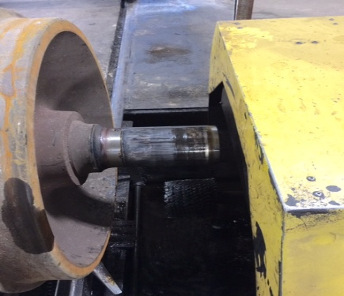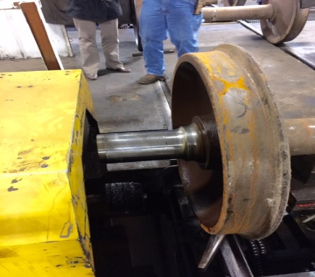

After
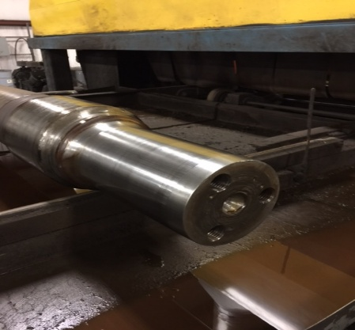

PROPERTIES

Appearance: Clear Liquid
Odor: Mild, lemony
PH: 12.0 (4% solution)
Flash Point: None
Lbs/Gal.: 8.34 lbs/g
Wetting: Complete
Foam: Slight to moderate
Penetration: Rapid
Rinsing: Complete
VOC None

FEATURES

Heavy Duty Multi-Surface Cleaner

Replaces solvents in axle washing and many other applications

Floor Scrubber Cleaner

Non-Ammoniated

Concentrated

Water-Based

