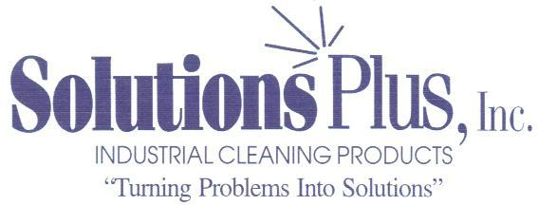
MAXI CLEAN FLOOR
CHEMICAL DATA
HIGH PERFORMANCE FLOOR CLEANER
DESCRIPTION
Maxi-Clean Floor is a heavy-duty, liquid alkaline floor cleaner designed for use in automatic floor scrubbing machines and with a mop and pail. Maxi-Clean Floor is excellent for removing grease, oil and rubber tire marks from all types of floors. Maxi-Clean Floor can also be used as a general purpose cleaner.
PROPERTIES
Appearance: Clear water white liquid
Odor: Mild
Specific Gravity: 1.03
Biodegradable: Yes
Rinsability: Excellent
APPLICATION AND USAGE:
Floor Scrubbing Machines: 1% to 5% Concentration
Mop and Pail 5% to 10% Concentration
PACKAGING
This product is available in 5-gallon pails, 55 gallon drums and 275 gallon totes.
ADDITIONAL INFORMATION
See Material Safety Data Sheet.

