

SOLUTIONS PLUS CHEMICAL DATA

Maxi Gard Steam

DETERGENT IRON PHOSPHATE & CLEANER

DESCRIPTION

Maxi Gard Steam detergent iron phosphate is a mildly acid liquid cleaner/phosphate designed for use in immersion, steam and high pressure (Hotzy type) systems. It is not recommended for recirculating spray washer applications. The Maxi Gard Steam produces a blue to gold coating on steel which provides an excellent surface for painting. The Maxi Gard Steam contains a synthetic surfactant and wetting system that is effective on even the most difficult soils.
Before Maxi Gard Steam
Using Maxi Gard Steam
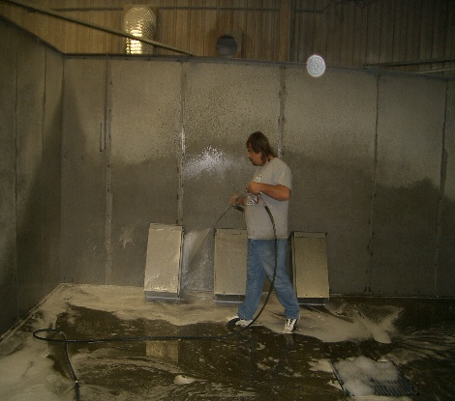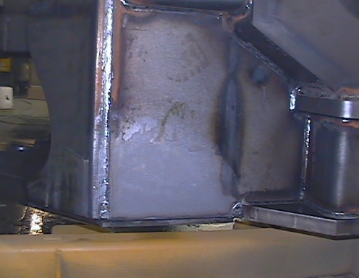

Sprayed with Maxi Gard Steam

PROPERTIES

Appearance: Clear amber liquid
Odor: None
PH (solution): 2.25
Solubility Complete
Specific Gravity: 1.11
Lbs./Gallon: 9.24

USING PROCEDURE:

Maxi Gard Steam is used in steam and high pressure washers at concentrations between 1% and 3%. For best results and to avoid streaking, start the cleaning and phosphatizing operation from the top of the part. In immersion operations the recommended concentration is between 2% and 6%. The normal operating range is 1-6 minutes at 100F. to 185F. In immersion operations the Maxi Gard Steam stage is generally followed by a cold water rinse and a non chrome sealer. The parts should be dried as quickly as possible after the final process.

TITRATION PROCEDURE

Obtain a representative sample of the bath and cool it to room temperature. Place a 10 mL bath sample in a 250 mL test cylinder. Dilute with 90 mL of DI Water. Add 3 to 4 drops of Phenolphthalein indicator. Swirl the sample to mix the indicator into the bath. While swirling the sample, add 6N Sodium Hydroxide solution drop wise until the sample turns pink. Count the drops of 6N base needed to reach the pink endpoint and compare the drops needed to the chart below.

% Maxi Gard Steam Drops of 6N Base Needed

1.0% 1 drops

2.0% 2 drops

3.0% 3 drops

4.0% 4 drops

5.0% 5 drops

