Solutions Plus Technical Data

Maxi Sure Clean-LT

Industrial Cleaner/Degreaser
Very-Low Temperature Parts Washing Cleaner/Degreaser

Characteristics: Low Temperature Cleaner

Through the use of surface-active agents, Maxi Sure Clean-LT penetrates and loosens the bond of substrate oils, by lowering surface and interfacial tension even at low temperatures of 65° F. Oil droplets are coated with a thin film of surfactant and float to the surface of the cleaning solution and away from your parts and equipment. Since Maxi Sure Clean-LT does not emulsify or become saturated with tramp oils, it can be reused many times. This enables Maxi Sure Clean-LT to last longer than caustic cleaners. Maxi Sure Clean-LT prevents sludge buildup within your cleaning system: this translates into keeping the equipment free of scale and particulate buildup on and around heating coils and spray nozzles.

Maxi Sure Clean-LT

- Superior dilution ratios at low temperatures
- No solvents
- Non-flammable

Maxi Sure Clean-LT does not contain:

- Chlorinated hydrocarbons
- Heavy metals that interfere with heat-treating operations
- Aromatic compounds
- Nitrites

Other features:

- Maxi Sure Clean-LT is nontoxic, nonflammable, and non-corrosive and Biodegradable.
- Maxi Sure Clean-LT is not harmful to equipment or personnel.
- No special handling or ventilation system is necessary.
- Maxi Sure Clean-LT has an indefinite shelf life.
- Maxi Sure Clean-LT can be calibrated simply by measuring the pH.
- Maxi Sure Clean-LT cleans at very low temperatures without foaming

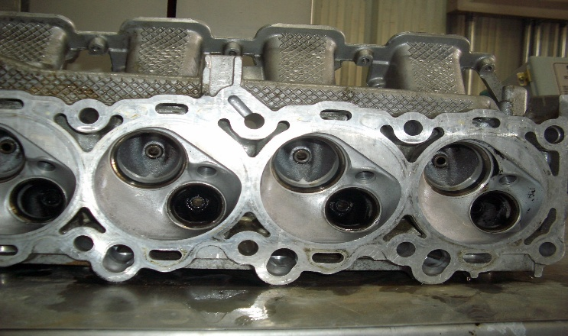

Cleaning Methods

Maxi Sure Clean-LT Industrial Cleaner/Degreaser is designed to remove dirt and oil. Maxi Sure Clean-LT has a strong affinity for oil and contaminants, and loosens them form the parts. Most oils float to the surface, where they can be removed easily by skimming wheels/belts, absorption blankets, or vacuuming. Turning off agitation allows solid particulates and fine metal particles to settle on the bottom, where they can be filtered off as sludge via recycling filtration systems.

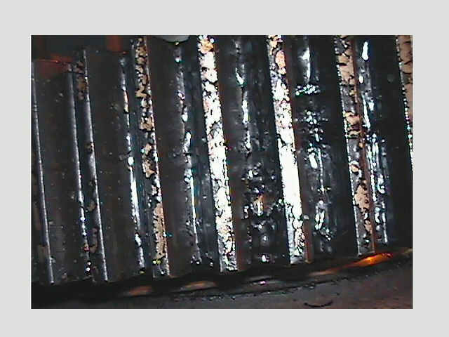
Gear Before Cleaned With Maxi Sure Clean-LT

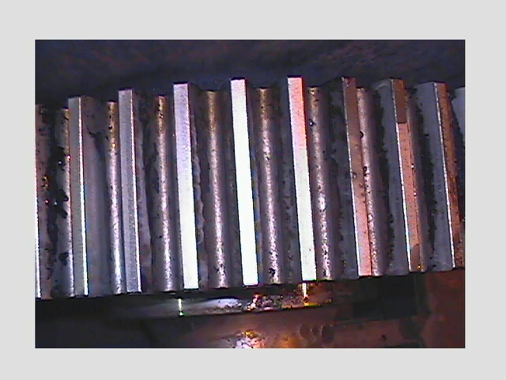

Gear After Being Cleaned With Maxi Sure Clean-LT

Heat and adequate agitation are important when using Maxi Sure Clean-LT unique formulation. Both heat and agitation can be produced by the following methods.
Parts Washers
Maxi Sure Clean-LT is a significant improvement over the caustic solutions commonly used in spray washers. Heated to 110 F Maxi Sure Clean-LT effectively removes oils and greases. Due to Maxi Sure Clean-LT low residue formula, in many cases no rinsing is required. Single-stage washing system is practical.

Ultrasonic Systems
Maxi Sure Clean-LT will remove oils, dirt, and fine metal particulates from surfaces that are agitated by ultrasonic systems.

Heat and
Agitation

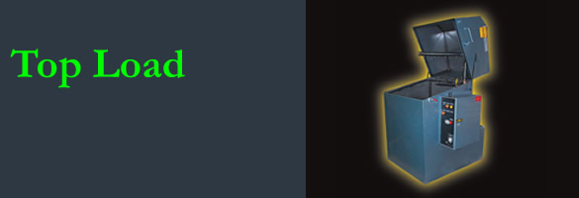

Aqueous Parts Washers
Maxi Sure Clean-LT can be heated to 165° degrees and replaces all hazardous caustics and acids in submersion washing systems. Parts washed in Maxi Sure Clean-LT and dried are protected from rust for 7 to 15 days. These parts can then be coated or bonded, without further treatment. Maxi Sure Clean-LT can also replace chlorinated hydrocarbons and other chemicals in a vapor degreasing tanks. These vapor tanks can be converted to a Maxi Sure Clean-LT submersion systems without costly equipment expenditures. We recommend this conversion for improved agitation to ensure cleaning effectiveness.

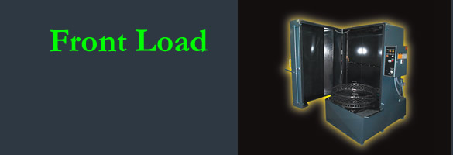

Oxygen and Compressed Gas Users

Maxi Sure Clean-LT Industrial Cleaner/Degreaser offers a safe, simple way to clean all metal parts without fear of high residue or damage to the environment. With proper agitation, pipe sections can be flushed clean. The temperatures can range from ambient to 145 degree. In addition, smaller hoses and parts can be submerged or sprayed.

Rinsability

Maxi Sure Clean-LT Industrial Cleaner/Degreaser leaves a minimum of nonvolatile residue for corrosion protection. In most cases this inhibitor does not have to be removed prior to subsequent metal finishing operations. After parts are completely dry, they are protected from rust for 7 to 15 days. These parts can then be coated or bonded, without further treatment.

Recycling

Although oil and grease are readily “lifted” from parts by Maxi Sure Clean-LT Industrial Cleaner/Degreaser, the cleaning quality can deteriorate rapidly if contaminants remain in the washing systems. In addition, recycling will improve the longevity of the cleaning solution. Recycling systems available to remove suspended oils and extend bath life: decanting, membranes, and micro filtration units.

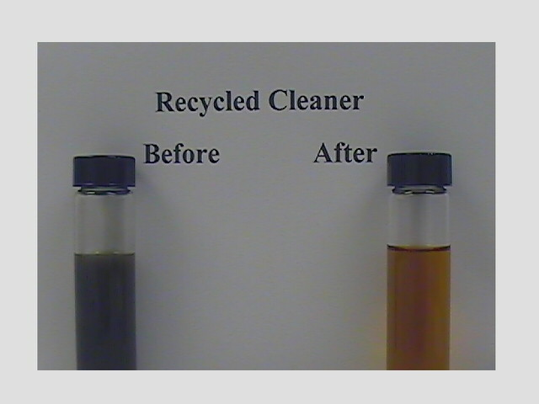

Disposal

Maxi Sure Clean-LT Industrial Cleaner/Degreaser can be disposed of quickly and inexpensively. After removing excess metal particulates and tramp oil, the saturated solution can be disposed of through your sanitary sewer system when local EPA ordinances are observed. Unlike harsher chemicals, Maxi Sure Clean-LT reduces the potential for regulatory penalties by the EPA and OSHA.

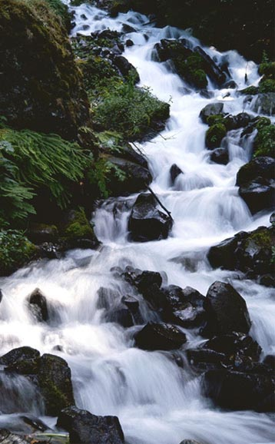
MAXI SURE CLEAN-LT
Creating a Cleaner Environment

Through Pure Chemistry

