
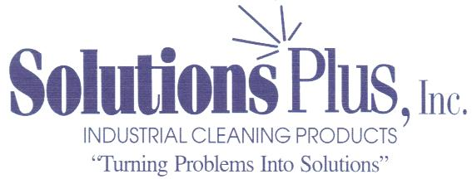
9001-2008 Certified Member

NANO PLUS – ST

NANOTECHNOLOGY PRETREATMENT

NO PHOSPHATES – CAN BE USED AT AMBIENT TEMPERATURE

Product Description:

Nano Plus – ST is a pretreatment product designed to replace both Iron and Zinc Phosphate pretreatment products prior to paint. The Nano Plus –ST contains no phosphates and no heavy metals and can be operated at ambient temperatures. It can be used on steel, aluminum and zinc alloys to produce a conversion coating that provides excellent paint adhesion and corrosion resistance. This Transitional Metal (Environmentally Friendly) based pretreatment can be used in 3, 4 and 5 stage spray and immersion systems. Other advantages compared to traditional Iron and Zinc Phosphate include reduced contact time and less sludge which equates to longer tank life and reduced cost.

Physical Properties:

Appearance: Clear Blue Liquid
Odor: None
Specific Gravity: 1.0

Operating Conditions:

Concentration: 1.0 to 3.0%
Temperature: Ambient to 110 F.
pH ( Steel and Iron) 3.8 to 4.8
pH (Aluminum and Galvanize) 2.5 to 3.5

Waste Disposal:

When it becomes necessary to discard the working tank solution, neutralize the tank before discarding.

