SOLUTIONS PLUS CHEMICAL DATA

Neutral De-Rust & Cleaner

GENERAL DESCRIPTION
Neutral De-Rust & Cleaner is a neutral pH corrosion remover based on organic phosphate technology. This product can be used in recirculating spray, immersion, and spray wand applications. Neutral De-Rust & Cleaner is designed to remove metal oxides, including rust, weld smut, and laser slag from ferrous metals. Neutral De-Rust & Cleaner is also used for corrosion removal and brightening of aluminum, copper, and brass.
Below pictures show results at 10% @ 160 degrees for 2 minutes
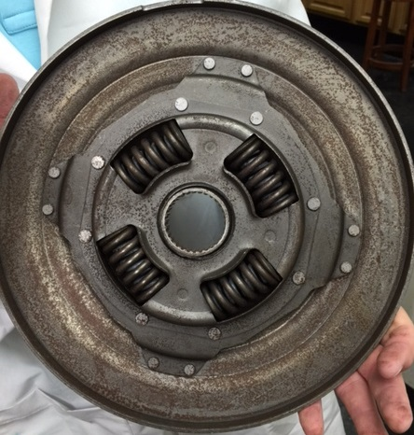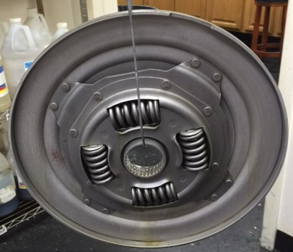

Before After

Physical Properties:

pH Neat 6.0 to 7.0

Flash Point >200

Specific Gravity 1.35 to 1.39

Lbs/Gallon 11.23 to 11.56

DIRECTIONS FOR USE
Operating concentrations of Neutral De-Rust & Cleaner range from 5% -50%, depending on the application.
Acceptable operating temperatures range from ambient to 140°F to 160. For rust removal, Neutral De-Rust & Cleaner should be applied at a starting concentration of 5% by volume. Consult your SPI Sales Manager to establish the optimum operating criteria for your operations.

