Cleaning Methods

Pure Clean Industrial Cleaner/Degreaser is designed to remove dirt and oil. Pure Clean has a strong affinity for oil and contaminants, and loosens them form the parts. Most oils float to the surface, where they can be removed easily by shimming wheels/belts, absorption blankets, or vacuuming. Turning off agitation allows solid particulates and fine metal particles to settle on the bottom, where they can be filtered off as sludge via recycling filtration systems.

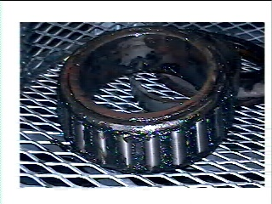
Bearing Before Cleaned With Pure Clean

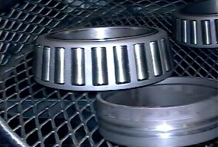

Bearing After Being Cleaned With Pure Clean

Heat and adequate agitation are important when using Pure Cleans unique formulation. Both heat and agitation can be produced by the following methods.

Parts Spray Washers

Pure Clean is a significant improvement over the caustic solutions commonly used in spray washers. At a dilution of 3% (1:30) with water, heated to 140 F, Pure Clean effectively removes oils and greases. Due to Pure Cleans’ low residue formula, spray nozzles stay clean from soil build-up. No rinsing is required, single-stage washing system is practical.

Ultrasonic Systems
In a 5% solution, Pure Clean will remove oils, dirt, and fine metal particulates from surfaces that are agitated by ultrasonic systems.

Heat and
Agitation

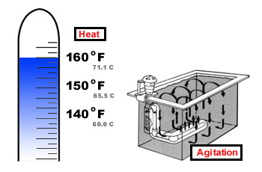

Heated Dip Tanks
A 5% solution of Pure Clean heated to 150 degrees replaces all hazardous caustics and acids in submersion washing systems. Parts washed in Pure Clean and dried are protected from rust for 7 to 15 days. These parts can then be coated or bonded, without further treatment. Pure Clean can also replace chlorinated hydrocarbons and other chemicals in a vapor degreasing tanks. These vapor tanks can be converted to a Pure Clean submersion system without costly equipment expenditures. We recommend this conversion for improved agitation to ensure cleaning effectiveness.

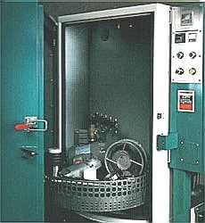

Oxygen and Compressed Gas Users

Pure Clean Industrial Cleaner/Degreaser offers a safe, simple way to clean all metal parts without fear of high residue or damage to the environment. With proper agitation, pipe sections can be flushed clean with 3% to 5% solution. The temperatures can range from ambient to 160 degree. In addition, smaller hoses and parts can be submerged or sprayed.

Rinsability

Pure Clean Industrial Cleaner/Degreaser leaves a minimum of nonvolatile residue for corrosion protection. In most cases this inhibitor does not have to be removed prior to subsequent metal finishing operations. After parts are completely dry, they are protected from rust for 7 to 15 days. These parts can then be coated or bonded, without further treatment.

Recycling

Although oil and grease are readily “lifted” from parts by Pure Clean Industrial Cleaner/Degreaser, the cleaning quality can deteriorate rapidly if contaminants remain in the washing systems. In addition, recycling will improve the longevity of the cleaning solution. Recycling systems available to remove suspended oils and extend bath life: decanting, membranes, and micro filtration units.

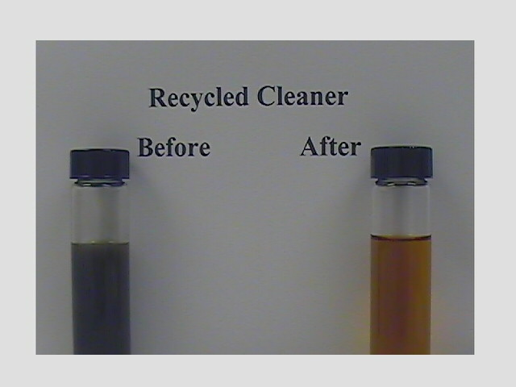

Disposal

Pure Clean Industrial Cleaner/Degreaser can be disposed of quickly and inexpensively. After removing excess metal particulates and tramp oil, the saturated solution can be disposed of through your sanitary sewer system when local EPA ordinances are observed. Unlike harsher chemicals, Pure Clean reduces the potential for regulatory penalties by the EPA and OSHA.

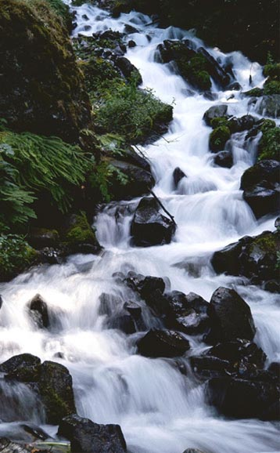

PURE CLEAN

Creating a Cleaner Environment

Through Pure Chemistry

Cost Advantage

Pure Clean is a biodegradable concentrate that dilutes in water. In a 5% solution, each 55-gallon drum provides 1,100 gallons of one of the most powerful cleaning/degreasing solutions on the market today.

Pure Clean Industrial Cleaner/Degreaser

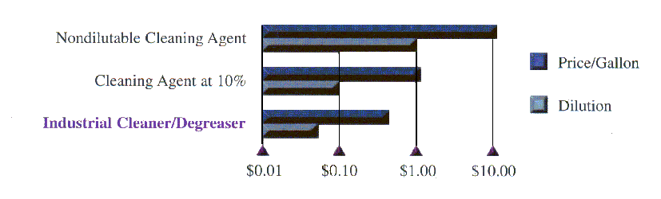

Characteristics

Through the use of surface-active agents, Pure Clean penetrates and loosens the bond of substrate oils, by lowering surface and interfacial tension. Oil droplets are coated with a thin film of surfactant and float to the surface of the cleaning solution and away from your parts and equipment. Since Pure Clean does not emulsify or become saturated with tramp oils, it can be reused many times. This enables Pure Clean to last longer than caustic cleaners. Pure Clean prevents sludge buildup within your cleaning system: this translates into keeping the equipment free of scale and particulate buildup on and around heating coils and spray nozzles.

Pure Clean contains the following compounds:

- Ionic and organic surfactants
- Glycol ether solvents
- Alkaline-based detergents

Pure Clean does not contain:

- Chlorinated hydrocarbons
- Heavy metals that interfere with heat-treating operations
- Aromatic compounds
- Amines, nitrites or other carcinogenic materials

Other features:

- Pure Clean is nontoxic, nonflammable, and non-corrosive.
- Pure Clean is not harmful to equipment or personnel.
- No special handling or ventilation system is necessary.
- Pure Clean has an indefinite shelf life.
- Pure Clean is blue in color but may fade or change color but
will have no effects on it’s performance.
- Pure Clean can be calibrated simply by measuring the pH.

Pure Clean Industrial Cleaner/Degreaser has successfully gone through the NSF Review Process.
______________________________________________________________________________________
For more information, contact:
Solutions Plus, Inc. 3907 Bach Buxton Road, Amelia Ohio, 45102
Tel: (513-943-9600 1-888-943-1100 Fax: (513)-943-9609

