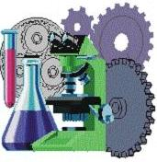

SOLUTIONS PLUS CHEMICAL DATA

RP ULTRA
ULTRA RUST PREVENTATIVE

DESCRIPTION

RP ULTRA is an outstanding effective water displacing, non-staining rust preventive which will not emulsify even in the presence of alkali, and will quickly separate water displaced from metal surfaces after machining operations or after alkali cleaning. The protective film of RP ULTRA is non-staining and highly protective.

RP ULTRA meets MIL-C16173D, Grade III. RP ULTRA is fast drying and leaves a film which will provide years of indoor rust protection. This film has lubricity for added manufacturing advantages. When metal is coated with RP ULTRA it can prevent rust from forming for many months and in some cases years, when left outdoors. This will depend on atmospheric conditions and exposure.

RP ULTRA After 60 Days Outside Storage
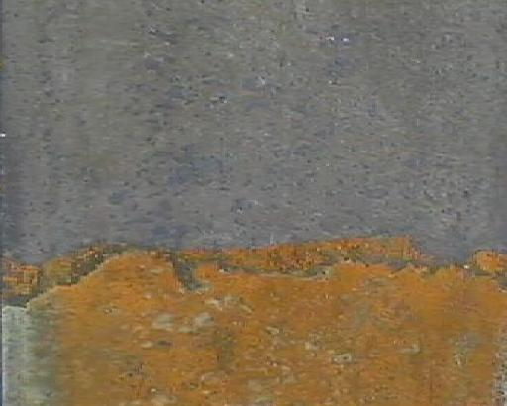
Without RP ULTRA

PROPERTIES

Appearance: Brown liquid
Odor: Mild
Specific Gravity: 0.796
Lbs/Gal.: 6.64
Viscosity (SUS) 245 @ 100 degree

PERFORMANCE TEST RESULTS

A. Water Displacement and Depletion Test

The water displacing properties of RP ULTRA solutions were determined by putting a coated steel panel into a heated wet humidity chamber for 6 days. After such time, water was displaced and no rusting of steel panel accrued.

RP ULTRA with 1% NaOH was carried out. After separation of the caustic solution, all performance tests were run on the “extracted” solution, with no reduction of any of its desirable properties.

B. Non-Stain Test
Panels coated with the test solution and water are “sandwiched” and stored at 82.2 C (180F) for 24 hours. Appearance of a black stain is cause for failure. RP ULTRA passes this test and has also proved its non-staining characteristics during extensive industrial usage.

Using Procedures

RP ULTRA can be cleaned off of parts with a mild alkaline cleaner.

RP ULTRA can also be diluted with mineral spirits, but by doing so it may shorten the rust protection.

For ultimate rust protection, use undiluted.

