SOLUTIONS PLUS CHEMICAL DATA

RAIL TECH-2
PASSENGER CAR, LOCOMOTIVES.CONSTRUCTION EQUIPMENT

DESCRIPTION

Rail Tech-2 is a heavy-duty, liquid alkaline cleaner used for locomotives, construction equipment, railcars, and passenger cars. In addition, it provides a wide range of uses in the railway, transportation and industrial market place. Rail Tech-2 was specifically designed to penetrate and remove the toughest greases and road soils. It is an excellent steam cleaner, all surfactants are biodegradable, emulsification is rapid and it is free rinsing.

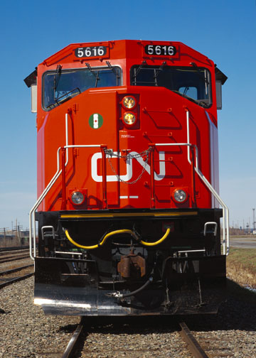

PROPERTIES

Appearance: Clear liquid
Odor: Mild
pH (concentrate): 13.0

Foam: Medium
Solubility: Complete
Phosphates: None
Flash Point: None
Specific Gravity: (8.9 lbs. Gal.)

Benefits:

Biodegradable, Rinsing Quick and Complete, Designed for Railway Type Soils, Compatible with most waste treatment systems, easy –to-use, non-petroleum based, no hydrocarbons, excellent using cost.

USING PROCEDURES

1:20 to 1:100

DISPENSING Chemical spray arches, steam guns, high pressure spray guns, brush

_____________________________________________________________________________________________
Solutions Plus, Inc, 3907 Bach Buxton Road, Amelia, OH 45102
513-943-9600 Fax 513-943-9609

