SOLUTIONS PLUS CHEMICAL DATA

RAIL TECH ULTRA PH
Heavy Duty Soak Wash/Etchant Cleaner

DESCRIPTION

RAIL TECH ULTRA PH is a heavy duty liquid soak tank/etchant cleaner. RAIL TECH ULTRA PH operates in a temperature range of ambient to185F and at concentrations from full strength to 10% depending on the severity of the soil. Contains no chromates, phenols, or cresols. Use on oil and air filters, sintered bronze filters, heads, liners, gear cases, pistons, engine blocks, wheel bearings, pre-cleaning metal before painting.

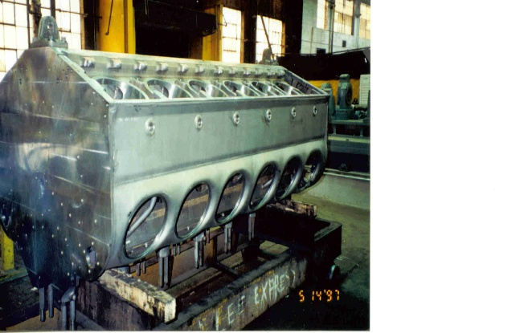

PROPERTIES

Appearance: Clear Amber
Odor: Mild
pH 13.5
Foaming (above 130 F) Medium
Solubility: Complete
Phosphates: None
Biodegradable Yes, all surfactants
Freeze Point 11°F

USING PROCEDURES

Use at full strength to 10% depending on severity of soil to be cleaned

