SOLUTIONS PLUS CHEMICAL DATA

SCRUB-AWAY

GENERAL PURPOSE FLOOR CLEANER

DESCRIPTION

SCRUB-AWAY is a heavy-duty, liquid alkaline cleaner used for general purpose cleaning. SCRUB-AWAY was designed to penetrate and remove tough greases and soils. It is excellent in floor scrubbers, can be used in manual spray wands as a foaming cleaner, and with a mop & bucket.

Powerful industrial cleaner that is certified as a Clean Air Solvent by the South Coast Air Quality Management District

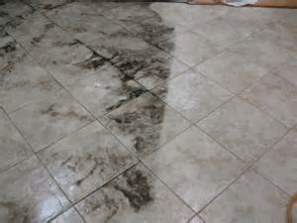
Before After
PROPERTIES
Appearance: Clear water white liquid
Odor: Mild
Specific Gravity: 1.062 (8.86 lbs/gal.)
Flash Point: None
Foam: Medium

USING PROCEDURES
Heavy soils 1:3 to 1:10
Medium soils 1:10 to 1:75

DISPENSING

Floor scrubbing machines, Manual Spray Wands, or hand scrubbing.

