SOLUTIONS PLUS CHEMICAL DATA

SOLV-A-CLEAN-143

SP510
DESCRIPTION

SOLV-A-CLEAN-143 is a vanishing type solvent cleaner used for traction motors, generators, and electrical oily surfaces. SOLV-A-CLEAN-143 dries rapidly and residue-free, allowing parts to be assembled faster.
SOLV-A-CLEAN-143 is non-staining and contains no chlorine or sulfur. SOLV-A-CLEAN-143 replaces chlorinated solvents that are unsafe for personnel and the environment.

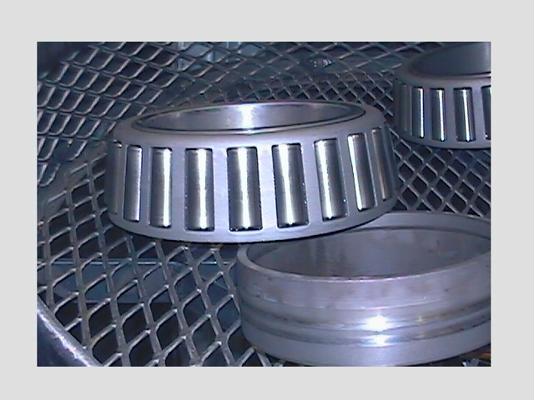

PROPERTIES

Appearance: Clear liquid
Odor: Low odor
pH Not measurable
Flash Point: 143
Safety Safe on all metals

USING PROCEDURES
Use SOLV-A-CLEAN-143 as received. It may be applied by normal techniques such as roll on, spray, brush, or wipe on. May be applied to parts for light lubrication.

MATERIAL SAFETY
Safe on all metals.
STORAGE
Store in a cool area away from flames or sparks.

Solutions Plus, 3907 Bach Buxton Road, Amelia, OH 45102
513-943-9600 Fax-513-943-9609

