SOLUTIONS PLUS CHEMICAL DATA

SPRAY WASH 9200
Heavy Duty Spray Wash Cleaner

DESCRIPTION

SPRAY WASH 9200 is a heavy-duty concentrated cleaner for spray washer applications. SPRAY WASH 9200 contains no chromates, phenols, or cresols. Use on oil and air filters, sintered bronze filters, Traction Motors, heads, liners, gear cases, pistons, engine blocks, wheel bearings and tank car interiors. It is especially designed for Mart and Proceco Washers.

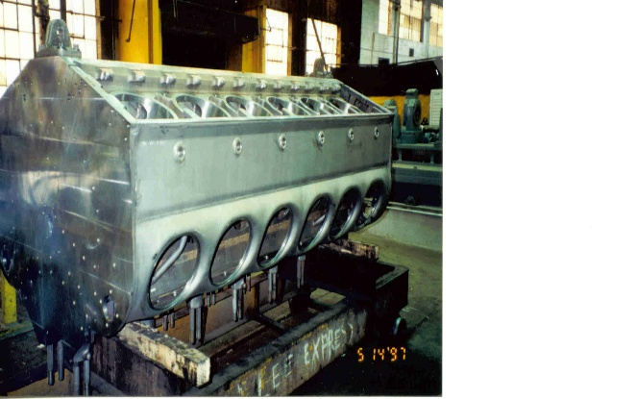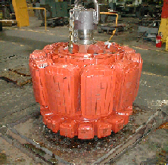

Most effective temperature ranges are above 165 F.

Avoid prolong contact with aluminum, zinc and other soft metals.

PROPERTIES

Appearance: Clear brown
Odor: Mild
pH 13.5
Foaming (above 130 F) Low
Solubility: Complete
Biodegradable Yes, all surfactants

