SOLUTIONS PLUS CHEMICAL DATA
SUPER CLEAN 2000

ELECTRICAL MOTOR CLEANER

DESCRIPTION

SUPER CLEAN 2000 is a liquid spray/soak cleaner specifically designed for the cleaning of electrical motor parts. It is a low foaming, low pH product for maximum cleaning and no damage to sensitive electrical parts. It is an effective cleaner on traction motors, generators, armatures and electric motors.

SUPER CLEAN 2000 will not attack soft metals or varnishes or C3 and C5 insulative coatings.

Meets G.E. and EMD approvals.
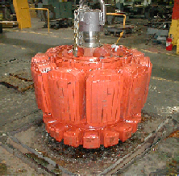

PROPERTIES

Appearance: Clear Yellow Liquid
Odor: Mild Surfactant
pH (Concentrate): 10.7
Foam: Low
Rinsing: Rapid
lbs/Gal.: 9.34

USING PROCEDURES

Steam cleaning - 2 to 5% by volume
Pressure washing - 2 to 5% by volume
Soak tank cleaning - 5 to 20% by volume
Use clean water to rinse SUPER CLEAN 2000 from all surfaces prior to
re-use. Do not leave parts in SUPER CLEAN 2000 overnight.

DISPENSING

Proceco Washers, Mart Washers or any other industrial spray washers.

