SOLUTIONS PLUS CHEMICAL DATA

TC 161 PLUS
Heavy Duty Spray Wash Cleaner

DESCRIPTION

TC 161 PLUS is a heavy-duty cleaner for spray washer applications. TC 161 PLUS Contains no chromates, phenols, or cresols. Use on oil and air filters, sintered bronze filters, Traction Motors, heads, liners, gear cases, pistons, engine blocks, wheel bearings and tank car interiors. It is especially designed for Mart, Proceco and many other types of washers.

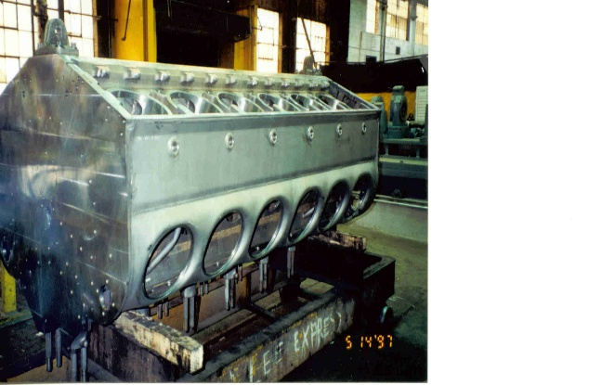

PROPERTIES

Appearance: Clear brown
Odor: Mild
pH 13.5
Foaming (above 130 F) Low
Solubility: Complete
Phosphates: None
Biodegradable Yes, all surfactants

