SOLUTIONS PLUS CHEMICAL DATA

Ultra Rig Plus
VEHICLE CLEANING
TRUELY TOUCHLESS CLEANER

DESCRIPTION

ULTRA RIG PLUS is a heavy-duty, liquid alkaline cleaner used for trucks, locomotives, railcars, and passenger cars. In addition, it provides a wide range of uses in the railway, transportation and industrial market place. ULTRA RIG PLUS was specifically designed to penetrate and remove the toughest greases and road soils. It is an excellent steam cleaner, locomotive cleaner and can be used for floor and pit cleaning, all surfactants are biodegradable, penetration is rapid and it is free rinsing. ULTRA RIG PLUS will not keep oils or greases emulsified. ULTRA RIG PLUS will not cause problems in the wastewater treatment plant like other cleaners that have high solvent or caustic contents.

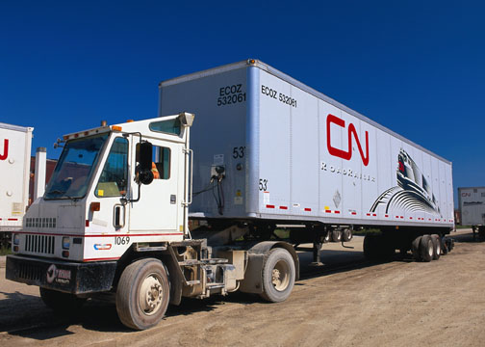

ULTRA RIG PLUS removes road soils even with systems that do not have brushes.

Titration: 10 MIL sample 3 Drops of indicator using 1 N Acid
2% = 7 Drops 12.01 pH….1%=4 Drops 11.4 pH.

PROPERTIES

Appearance: Clear colorless liquid
Odor: Mild
Foam: Medium
pH: 13 +
Solubility: Complete
Flash Point: None
Specific Gravity: 1.1965

USING PROCEDURES

1:50 up to 1:200. 1% is 1:100 ½% is 1:200.

DISPENSING

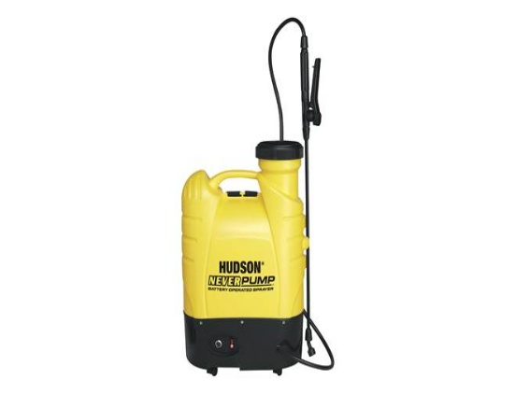
Unit is self-charging and last up to 6 hours

Pre-soak vehicle first with Ultra Rig Plus then rinse with high pressure.

Chemical spray arches, steam guns, high-pressure spray guns, brush or hand spraying.

MATERIAL SAFETY

Pre-test on rubber, neoprene, nylon and plastic before using. Pretest on paint, aluminum, and galvanized before using.

STORAGE

Keep from freezing. If frozen, thaw and mix to make usable.

