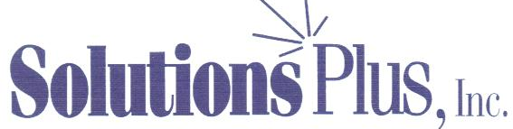
 Registered ISO 9001:2008 Manufacturer

INDUSTRIAL CHEMICAL PRODUCTS
Quality-Cost Savings-Service

WHIRL STRIP PLUS

Long Lasting Low pH Multi-Metal Paint And Resin Stripper

WHIRL STRIP PLUS is a highly active, non-phenolic, non-creosol non-chromate multi-metal paint and resin stripper. WHIRL STRIP PLUS can be used cold or heated to 145° to speed strip time.

WHIRL STRIP PLUS has the following advantages: WHIRL STRIP PLUS strips in approximately 10 to 15 minutes with most paints when heated to 140 to 180 degrees. To replenish or boost the WHIRL STRIP PLUS, WHIRL STRIP BOOSTER should be use at 2% to 4%.

- Non-phenolic
- Non-chromate
- Non-creosol
- Non-caustic
- Safe on all metals
- Low VOC’s
- Low odor
- Use at low temperatures
- Fast stripping power for many types of paints including powder coatings
- Can be recycled for very long tank life
- Over 200° flash point
- Non-regulated non-hazardous
- Safe to use, will not burn personnel
- Non-carcinogenic
- Low evaporation rate
- Can be used in dip tanks as well as spray washers
- Excellent cleaner for removing inks and pigments
- Low pH (7.5)

PROPERTIES:
Specific gravity 1.021
Flash 200°
Odor Low
pH 7.5
Color Clear
lbs/gal. 8.5
Metal Safety:
Safe on most metals, pre-test before using.
Using Procedures:

Use full strength undiluted. Can be mixed with other solvents but will impede the strip time.
Because of the WHIRL STRIP PLUS being able to be recycled, there is no need to dilute product. Using cost for WHIRL STRIP PLUS are excellent.

Part With Heavy Solid Paint Coating (15 Minutes) After Part Stripped in 15 Minutes

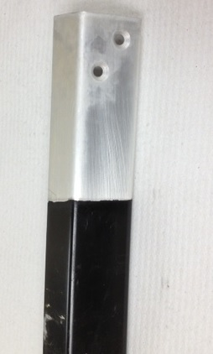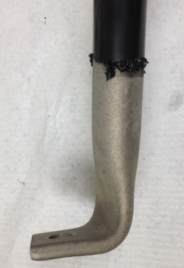

Cold Overnight

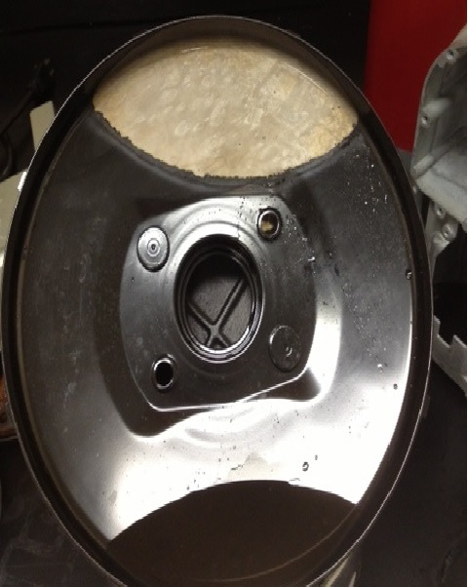

Titration Procedures For Whirl Strip Booster
All Tests Must Be In Glass Containers (No Plastic)

New solution of product: Take 300 mils. ( Ehrlenmeyer Flask of tap water, 5 mils.of product, 4 drops of Indicator solution (Phenolphalein), Solution will turn bright red. Add drops of 6N Acid, should clear at 24 drops, (+/-) 3 or 4 drops.

Procedure For Adding Whirl Strip Booster:

Add 5 mils. of bath water to 300 mils.of tap water to Ehrlenmeyer Flask. Add 4 drops of Phenolphalein (Indicator Solution), Solution will turn bright red. Slowly add drops of 6N Acid to solutions and keep count of drops until solution turns from red to cleaner. Look at chart to calculate amount of booster that should be added to bath solution.

Drops of 6N Acid Used Whirl Strip Booster To Be Added To Tank

24 drops 100% New Solution (Not Used)

Drops x .004 x the tank size is amount you need to add

Example: 20 drops on a 1000 gallon tank would be 24 minus 20 = 4 drops

Then you would take 4 x .004 x 1000 gallon tank = 16 gallon of Whirl Strip Booster to add.

Example #2: (22 drops would be 24 - 22 = 2 x .004 x 1000 gallons = 8 gallons

Example #3: (23 drops would be 24-23 = 1 x .004 x 1000 = 4 gallon to add to tank

24 drops 100% New Solution (Not Used)

23 drops 96 %
22 drops 92 %
21 drops 88 %
20 drops 88 %
19 drops 84%
18 drops 80%
17 drops 76%
16 drops 72%
15 drops 68%
14 drops 64%
13 drops 60%
12 drops 56%
11 drops 52%
10 drops 48%

